what do you have 和what do you do 的区别主要是意思不同，what do you have 中文译作：你拥有什么？而what do you do中文译作：你做什么？例如：

　　1.What do you have in mind?

　　你有什么想法?

　　2.We'd like some soft drinks for the lady. What do you have?

　　我们为这位女士要点软饮料. 你们有什么?

　　3.Now you've got your degree, what will you do?

　　你现在已经拿到学位了，打算做什么？

　　4.What can you do to keep it from happening again?

　　你怎样防止它再次发生？

what do you have in the kitchen？在厨房里你有什么？

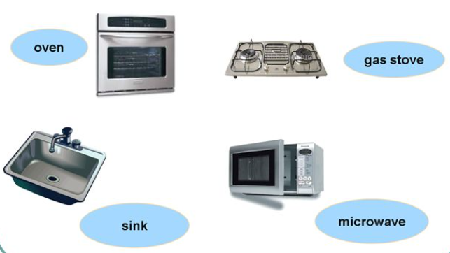

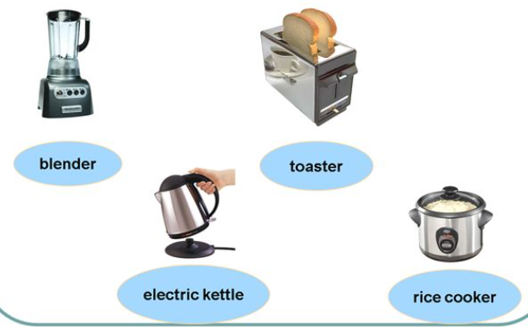

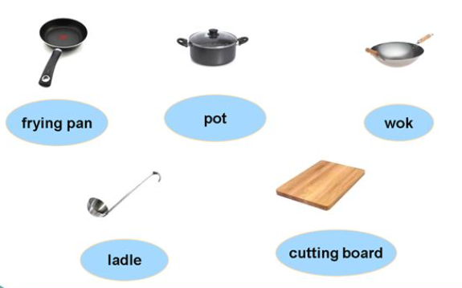

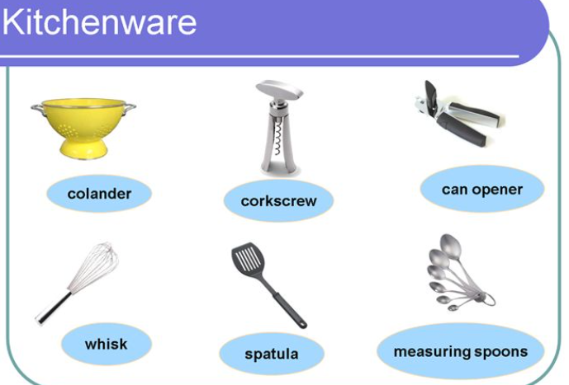

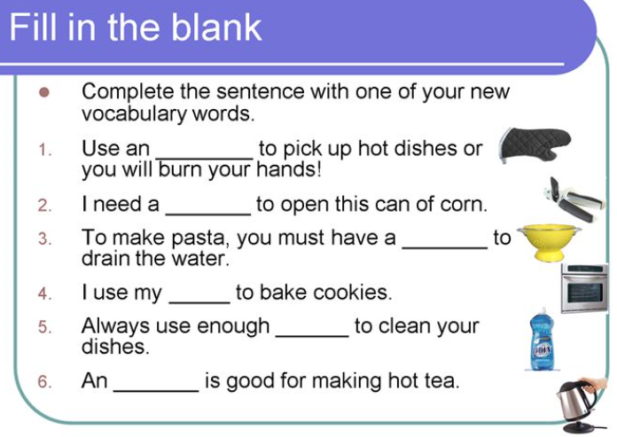

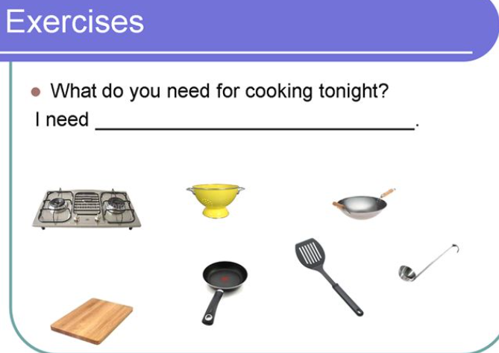

今晚做饭你需要什么

